Maven

Download maven from URL : <https://maven.apache.org/download.cgi>

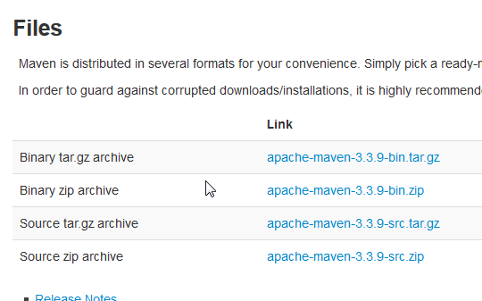

Make sure you have JAVA_HOME environment variable.

Unzip your maven.

Add “bin” directory from your maven folder to PATH environment variable.

Confirm by execute mvn –v on cmd.

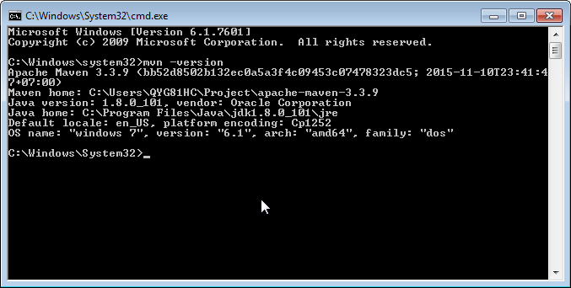

Config setting.xml

<your directory>\apache-maven-3.3.9\conf\setting.xml

Please input BOSCH’s proxy.

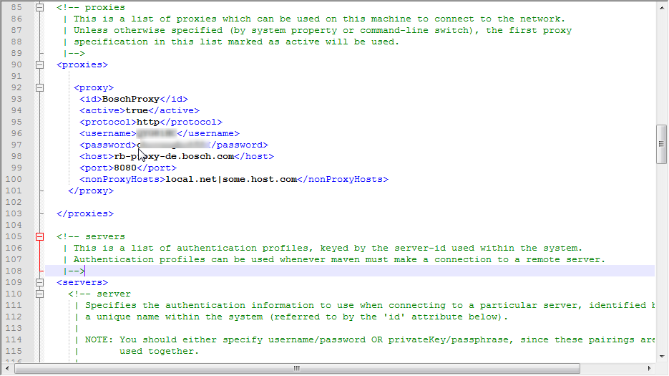

Maven Command line

For some reason please generate the archetypes of maven project first. ( this create a maven project )

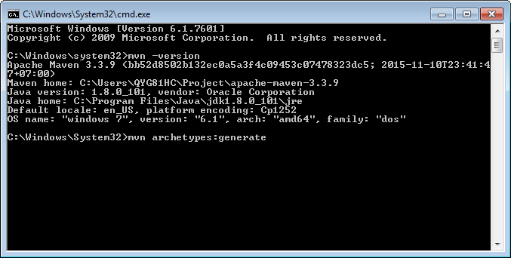

mvn archetype:generate -DgroupId={project-packaging}

-DartifactId={project-name}

-DarchetypeArtifactId=maven-archetype-quickstart

-DinteractiveMode=false

This tells Maven to create a Java project from the Maven maven-archetype-quickstarttemplate. If you ignore the archetypeArtifactId option, a huge list of the Maven templates will be listed.

Maven Spring Tool Suite.

Please go Window>Preference>Network Connections to input proxy.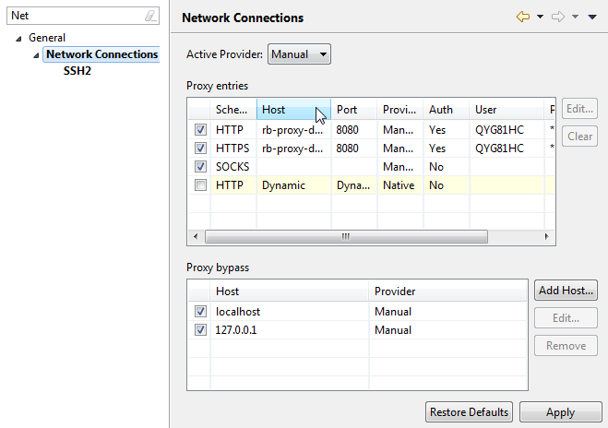Maven Configuration

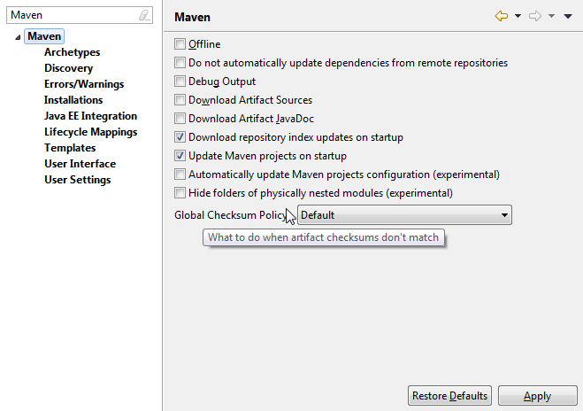

Tick download repository index updates on startup

Update Maven projects on startup.

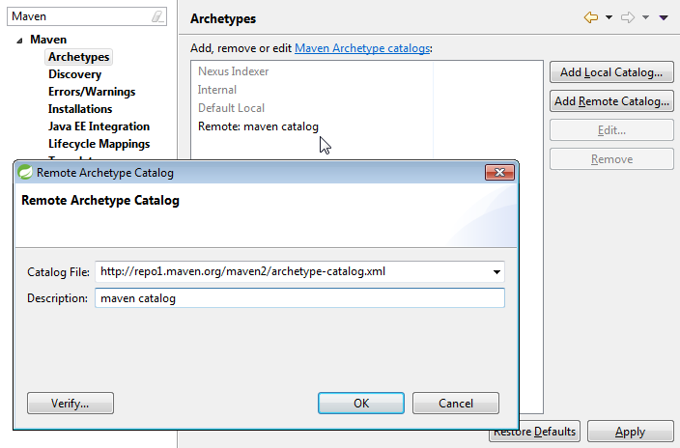

Create a catalog files update from update links.

Maven STS is embedded. It is recommended to use External maven downloaded from apache.org

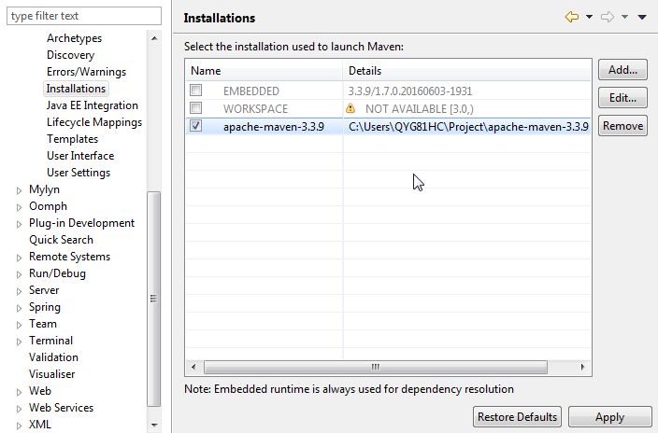

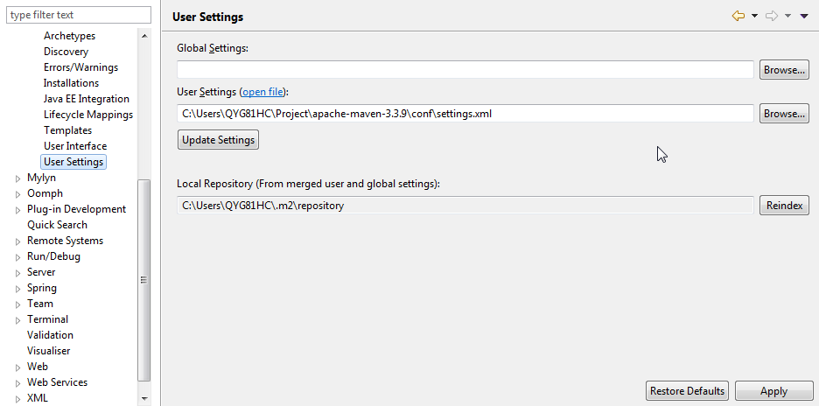

Please link your setting.xml files from maven folder to here.

Create maven project.

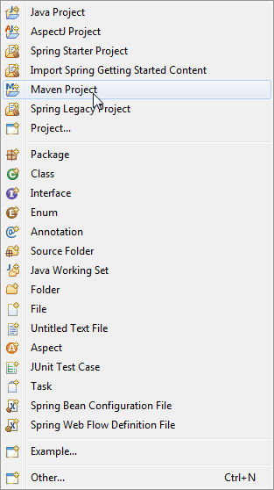

If errors happened please do this. This may cause from the connection with repositories.

Also please check your proxy again and again.

